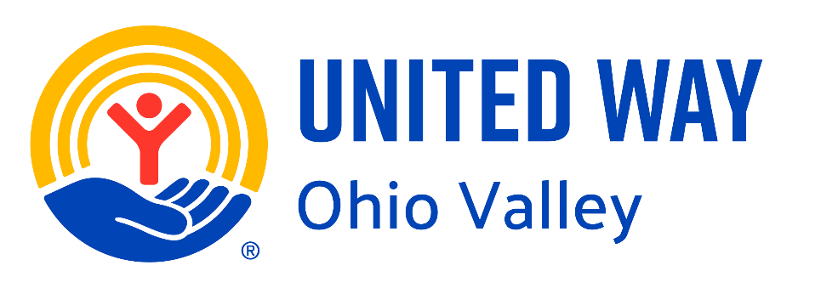
Did you know these Fun Facts about

United Way of the Ohio Valley?
- United Way of the Ohio Valley is part of a global network of United Way providers in over 30 countries, giving local donors access to worldwide expertise.
- The organization has a staff of only five serving six counties.
- The team has 70 years of combined nonprofit experience—nearly as long as the agency has existed.
- UWOV serves Daviess, Hancock, McLean, Ohio, Union, and Webster counties, providing a broad regional impact.
- The agency has been a trusted community anchor for 75 years.
- United Way of the Ohio Valley is a leader in the 211 system, connecting people 24/7 to critical services like food, housing, and crisis support.
- 211 also serves as a key part of disaster response infrastructure, ensuring rapid help during emergencies.
- UWOV staff and board actively participate in the Harwood Institute for Public Innovation and the Greater Owensboro Leadership Institute, ensuring community voices shape local solutions.
- The agency is recognized as a convener of nonprofits, businesses, and civic leaders.
- UWOV is not afraid to tackle tough issues like homelessness, affordable housing, and economic mobility.
- For over 15 years, UWOV has distributed free paper supplies to nonprofits monthly, saving each agency thousands of dollars annually.
- UWOV coordinates and conducts trainings for nonprofits, helping them strengthen capacity and achieve better outcomes.
- The agency provides much-needed funding year after year, offering nonprofits a consistent revenue source.
- Several long-term nonprofit partners are referred to as “Legacy Partners”, highlighting United Way of the Ohio Valley’s stability and commitment.
- UWOV created a second grant process called Impact Funding to address specific community needs and fund innovative programs beyond its Legacy Partners.
- Funding decisions are made by local community volunteers, not staff, ensuring transparency and community-informed priorities.
- UWOV volunteers review over 75 applications every year, and almost all volunteers take tours of agencies to learn more about their programs, making them more aware of community needs and services.
- UWOV is charged with raising over a million dollars each year, ensuring nonprofits can continue serving the community.
- UWOV keeps nonprofits accountable year to year, ensuring good business practices and measurable outcomes.
- Donors can trust their contributions are invested in data-driven, high-impact initiatives.
- United Way of the Ohio Valley supports early childhood education, childcare, after-school programs, and literacy initiatives.
- The agency funds programs addressing mental health, addiction recovery, and counseling services.
- United Way of the Ohio Valley invests in financial stability and workforce development programs, helping families achieve long-term independence.
- The agency balances immediate needs with long-term solutions, serving as both a safety net and springboard for opportunity.
- UWOV is a founding member of local nonprofit coalitions, fostering collaboration across sectors.
- The agency ensures less duplication and more results by coordinating efforts among nonprofits, businesses, and government partners.
- United Way of the Ohio Valley is a recognized voice of influence on community priorities and social issues.
- The agency collects and shares public knowledge from community conversations, strengthening local civic understanding.
- Thousands of families across six counties have received critical support through United Way of the Ohio Valley initiatives.
- The agency works alongside trusted Legacy Partners while also funding innovative new programs, balancing tradition with responsiveness.
- UWOV staff and volunteers distribute over 5,000 pledge forms each year, engaging the community in giving.
- You will see over 500 yard signs across the community with red, blue, and yellow messaging each campaign season.
- UWOV conducts over 150 business campaigns every year, mobilizing local workplaces to support community initiatives.
- United Way of the Ohio Valley helps connect businesses with nonprofit volunteer projects, building stronger teams and positive workplace culture.
- United Way of the Ohio Valley's Small Business Walk Campaign in Union County has been recognized as a national model for rural county philanthropy in 2025, showcasing innovative community engagement.

